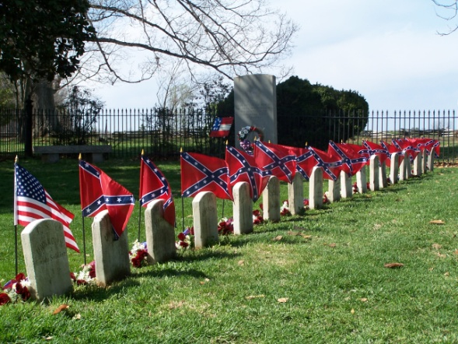

The Appomattox Chapter 11
United Daughters of the Confederacy
cordially invites you to attend the
Appomattox UDC Annual Memorial Service
at the Appomattox UDC Cemetery
(Route 24 next to the National Park in Appomattox, Virginia)
Sunday, April 7, 2024 at 2:00 p.m.

Please help us remember the fallen soldiers from the War
Between the States buried in the Appomattox UDC Cemetery.

If you or your group would like to present a wreath in this service, please respond by Friday, March 29, 2024 so the program can be updated to include all presenters and group names.

Mrs. Marjorie (Karen) Sale
President, Appomattox UDC Chapter 11
(434)993-6113
nngrits@yahoo.com

